Ashmal Irfan

Dylan Ionnotti and Timmy Pollard

POE- Block 2

9/25/15

1.1.6 Compound Machine Design

Design Problem

The task is to lift a weight of 8 ounces a vertical distance of 6 inches in less than 3 min and at the same time learn more about simple machine and experience the capabilities and limitations of VEX components as a group.

I must understand how the elements of design can change the mechanical advantage and how to compare the efficiency of different simple machines. The effort must be by human effort only. The final design must have 3 different mechanisms. I must have two simple machines and a gear system;either a pulley and a belt systems or a sprocket and chain system. Each is required to a mechanical advantage of at least one. The final must have a mechanical advantage of greater than one.

Brainstorm Idea

On the image above shows my brainstorming of the 1.1.6 project. The machine starts from the left of the image. The crankshaft gets moved in a clockwise direction by human force which moves sprocket also in a clockwise direction. The sprocket moves Gear C which rotates the wheel and axle which rotates the rope around the wheel and axle through the pulley and eventually lifts the half a pound of weight up the inclined plane.

Final Design Proposal
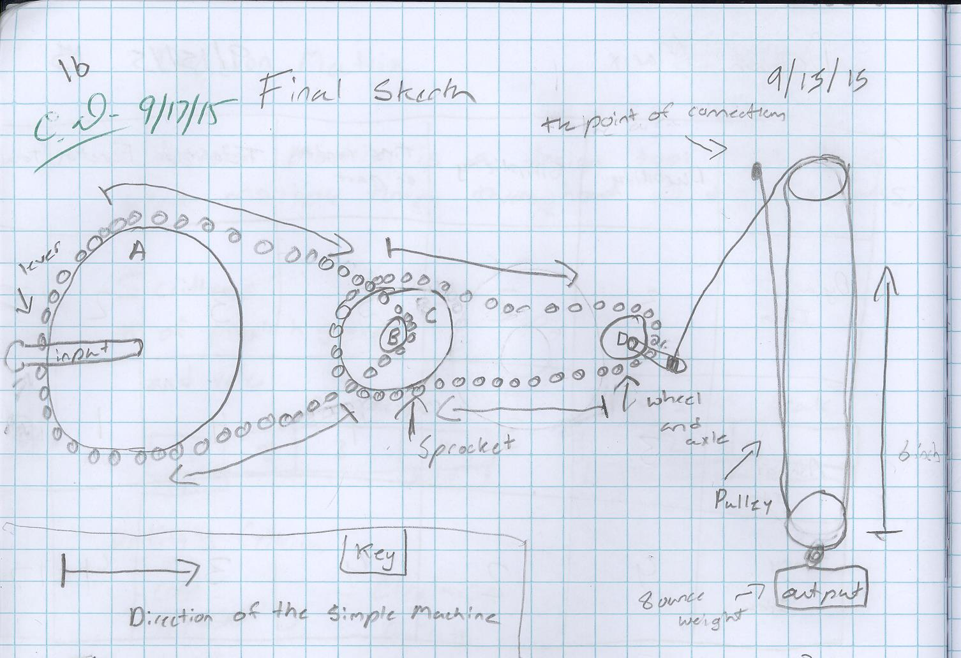
The final sketch shows 3 simple machines and also 2 spockets. the machine starts at gear A. The lever turns the sprocket clockwise to gear B which is a smaller gear, which rotates gear C because gear B and C are on the same axle. Gear C rotates the sprocket to gear D. Gear D has an axle which rotates the rope around axle on gear D which lifts the block and tackle and the package lift up 6 inches.

Design Matrix
 | Durability | Simplicity | Time Needed | Testability | Function | Test
Dylan’s Idea | 3 | 2 | 3 | 3 | 2 | 13
Ashmal’s  idea | 3 | 3 | 4 | 4 | 1 | 15
Timmy’s Idea | 4 | 2 | 4 | 3 | 4 | 17

All ideas were great but some lacked important details. My idea had a big problem with function because we were not sure it was going to work. Dylan's idea lacked Simplicity and Function but had a lot of good other topics. Timmy’s came up to the best because it was rated well in every scale

Design Modifications
- The first modification from our project was a very important one, it was changing from the cardboard frame to the frame included in our kit provided. Switching from the kits helped the gears stay in place and straight so the sprockets wouldn't keep slipping.
- The second modification from our project was the pulley system (block and tackle). It did not have enough clearance to get the required 6 inches so we added an extension, to get more than the required system.
- The third modification from our project was the format of our gears. Originally in our design we had the gears for our sprockets to be in a straight manner but changed the format so it could work with the frame we had made.
- The fourth modification from our project was to change the kind of rope. We had to change to a thicker rope because the thin rope couldn’t handle the weight of the load and the speed of the block and tackle pulley.
- The fifth modification from our project was to add spacers. spacers were needed because the gears had to have space in between so the sprocket would stay straight and prevent the sprocket from slipping.

Final Design Presentation
A crank powered by human force is rotated, the crank turns gear A to gear B which is sprocket A. Gear B shares a axle with gear C. Gear C goes to gear D which is sprocket B. Gear D shares a axle which the block and tackle and the rotating helps lift the load up the required 6 inches.
1.)IMA of the Wheel and Axle (Crank and Gear A)
IMA = DE/DR = 1.125/2 =.5625. It's all in inches.
2.)MA Gear A & Gear B
GR=n out/n in =12/30 =0.4. (teeth)
3.)MA of Gear B & Gear C
GR=n out/n in =24/12 =2. (teeth)
4.)MA of Gear C & Gear D
GR= n out/n in =18/24= .75 (teeth)
5.)IMA of Gear D to Axle
IMA= De/Dr= 1.25/.75= 1.667 (inches)
6.)IMA of Block & Tackle
4 Supporting strands
IMA= # of Supporting strands = 4
AMA=.51
Efficiency=22.3
This project took me and my group 2 class period due to the major modifications.

Final Working Project
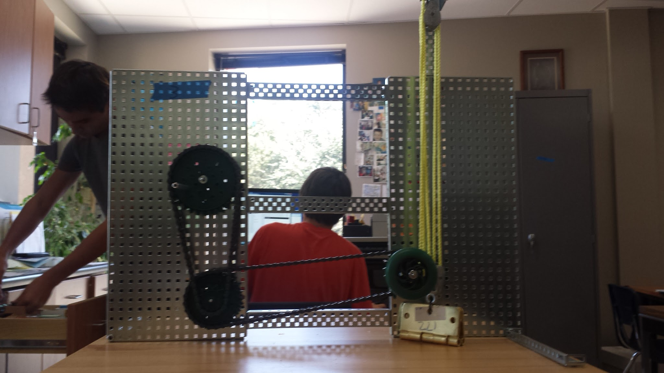

Team Evaluation
Timmy Pollard-
Timmy performed well and provided a lot ideas to help us. He would let us share the work and never would do most of the work. He did follow the group norms and had good communication.
Dylan Ionnotti
Dylan was great to work with he would provide great ideas when you have problems. As like Timmy he would never do all the work and let everyone have a fair share. He followed the group norms and had a good communication.
Me! (Ashmal Irfan)
I felt like i had great commutation and did my share of the project as professional as possible. I had followed the group norms and was on task most of the time.

Post-Mortem (Reflection)
1.)The easiest to simple machine we had to find the MA was the block and tackle because all you have to do is count the strands of rope.
2.)The most difficult simple machine to find the MA was the crank because the spring machine was not designed for cranks and that made it harder.
3.) Only add one sprocket instead of two and change the crank to a wheel that a human could rotate.

