Ashmal Irfan
Jake Hebert and Dylan Ionnotti
POE- Block 2
12/4/15
2.1.9 Truss Design

Problem Statement
Objectives
My group and I will need to understand why trusses are used in terms of efficiency and strength. My group and I will observe the performance of joints members, gussets and supports in trusses, and see how construction affects performance. My group and I will interpret test results, and providing reasons for the trusses performance. Determine if they are good or bad. I will work with my team, produce group norms, and use a decision matrix.
Criteria
To design a truss based on tests and research that performs better than test trusses. Your truss will be evaluated for quality (total force) and efficiency.
Constraints
My group and I must only use balsa wood, hot glue, and paper. Paper gussets must not be larger than the gussets used during testing. Must fit in apparatus (span >/ 6 7/8 inches; Height </ 4 5/8 inches.) My group and I must use no more than 36 inches of balsa wood. Wood can be bought for 1 point per inch.

Test Truss
Our test truss was simple; it was just a triangle with a line through the middle. While our test truss was going through the intense pressure, I started to hear cracking and then it just broke on the bottom left side of the truss, due to the pressure and the downward momentum and the whole truss broke up into many pieces.
Due to problem with the truss software, not graph was produced.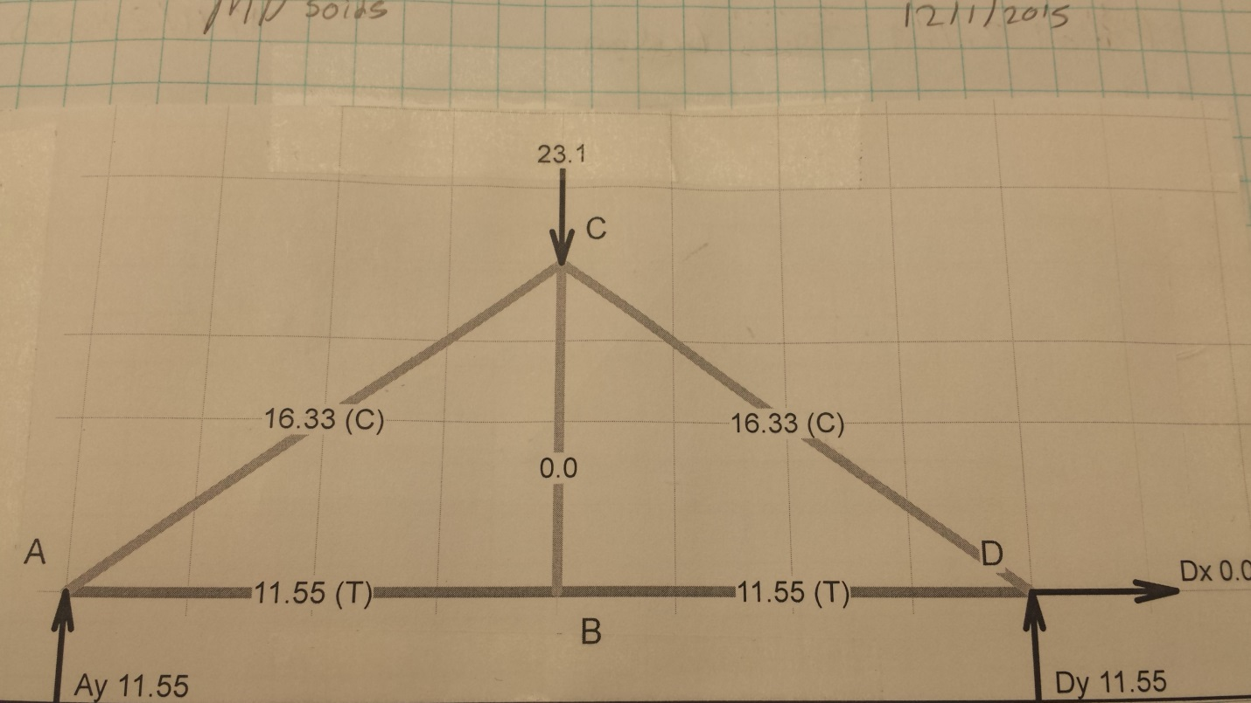
I learned many thing from this truss it showed use that its important no to have it way to long and to make sure to have all the weight evenly disturbed through the truss. For example, in this truss there was a lot of force on the side ways support so we should put supports in between too made them stronger.

Research Results
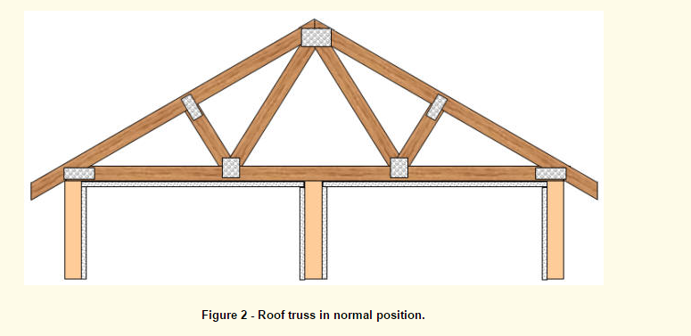
This roof truss was great and everything I was looking for, of course, I would make some change but it was a great start. This truss showed that everything was even so the weight would be equally around the truss.
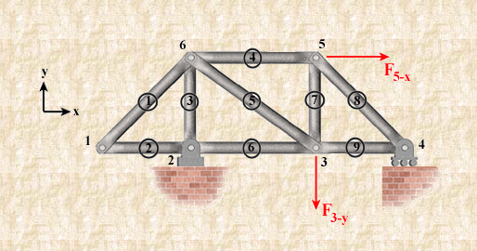
This truss was great but I was not too sure about it due to past experiences I had making this truss in middle school. I remember it having problems in the middle and just crack through the middle. It was a great find but not the best.
"Analysis of Statically Determinate Trusses." Trusses, Frames and Machines: Analysis of Statically Determinate Trusses. N.p., n.d. Web. 01 Dec. 2015. <http://www.ae.msstate.edu/vlsm/truss/analysis_of_statdet_trusses/zfm.htm>.
"How To Repair Roof Truss Up-Lift." How To Repair Roof Truss Up-Lift. N.p., n.d. Web. 01 Dec. 2015. <http://www.renovation-headquarters.com/roof-truss-uplift.html>.

Design Idea
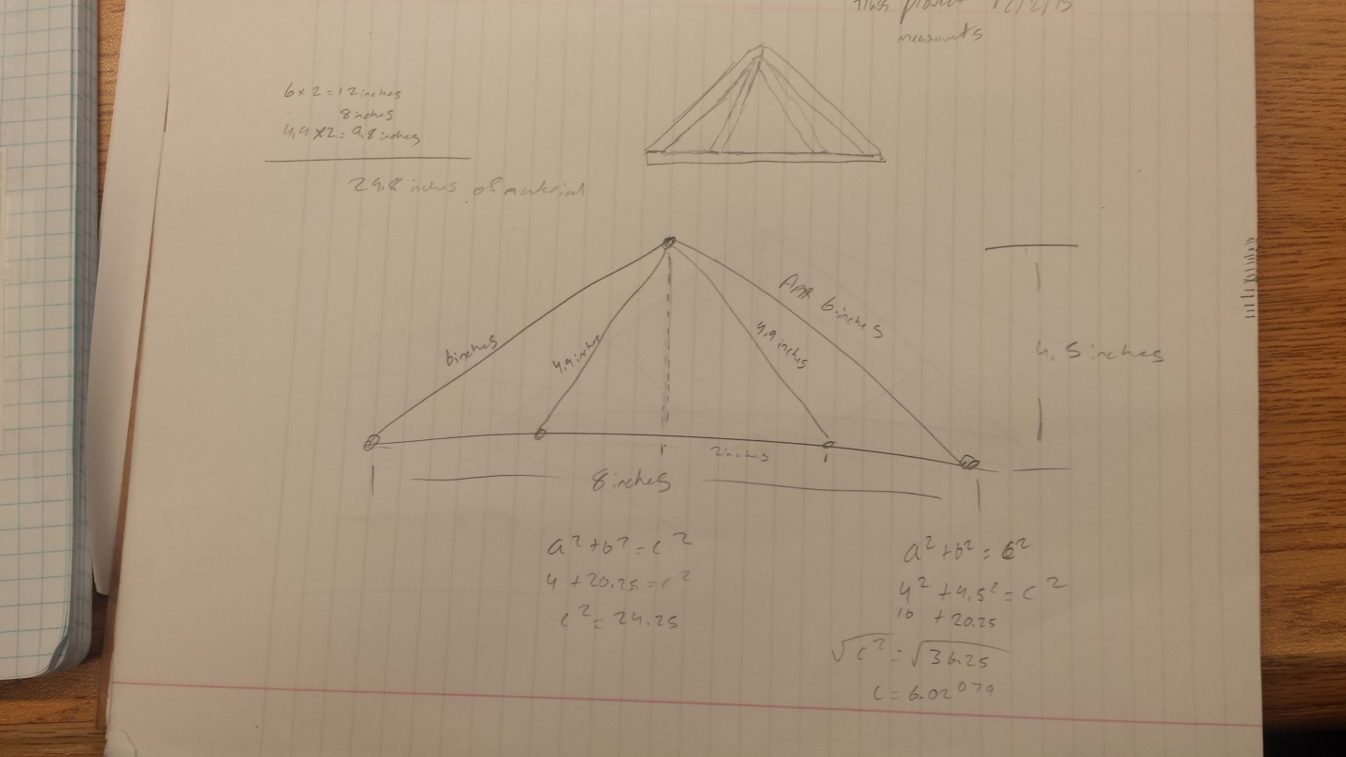
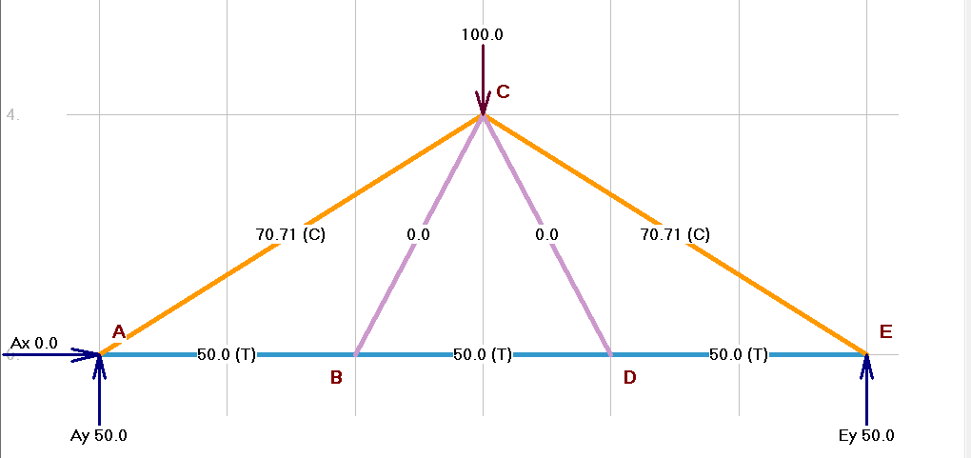
The total material needed, theoretically should be 29.8, but if I account for error it should be 31 inches of balsa wood.

Decision Process
Name | Ease of constructing | Strength | Materials Needed | Time needed | Total
Ashmal | 3 | 2 | 4 | 3 | 12
Jake | 3 | 4 | 3 | 3 | 13
Dylan | N/A | N/A | N/A | N/A | N/A
My design was great in some aspects of design but lacked the important categories. Constructing the truss would be pretty easy besides having to be very accurate. The strength wasn’t to strongest due to the lack of supports within the truss. The materials needed was very good because I required to use only 30 inches from our 36 max. The total came out to 12

